**Virtual Event Social Media Toolkit – Gathering for Good**

**Who is this toolkit for?**

HCI board members, staff, and virtual event hosts & attendees

**How do I use it?**

Use the sample posts and suggested hashtags to highlight the HCI virtual event on your preferred social media platforms (Facebook, Instagram, Twitter). Or create your own posts! You can also post pictures of your event and explain why you support and donate to HCI.

**Key messages:**

Healthy Community Initiative (HCI) is a backbone organization that works collaboratively with community partners to support youth from cradle to career. HCI acts on unwavering commitment to *all* of our community’s youth, building coalitions and striving for data-driven results. HCI supports more than 20 programs in Rice County that serve and benefit youth.

**Graphic(s) to download and share:**

*The HCI Gathering for Good social media - square format*

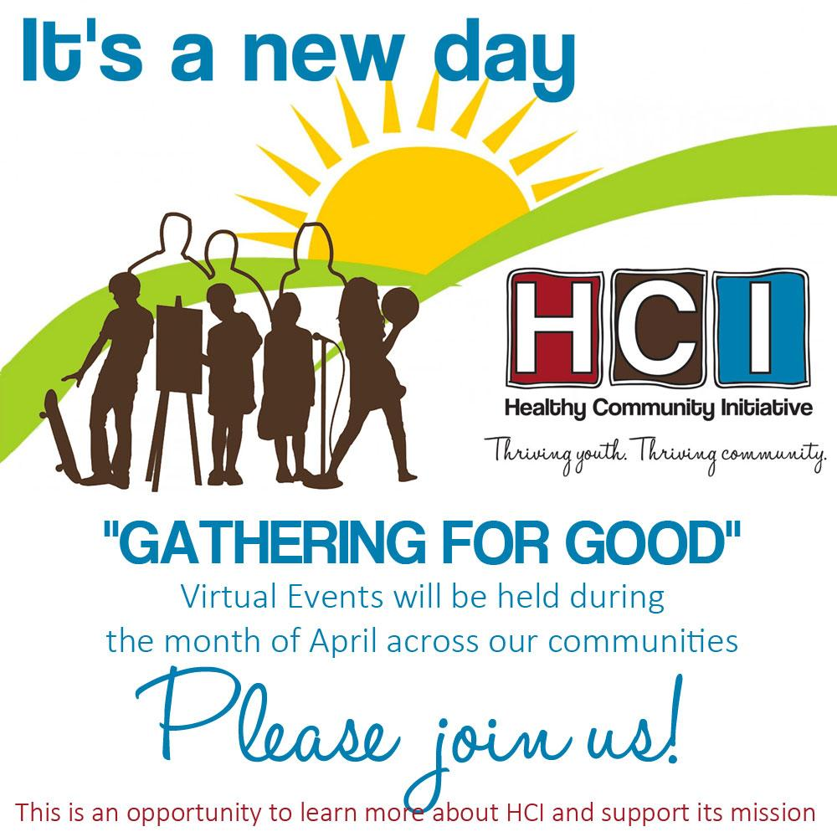

*The HCI logo:*

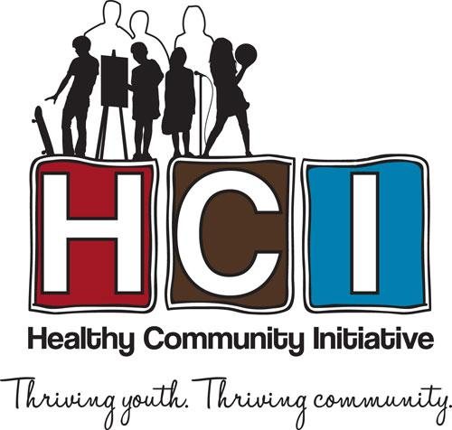

**Handles to know:**

Facebook: @healthycommunityinitiative

Instagram: @healthycommunityinitiative

Twitter: @RiceCountyHCI

**Event hashtags:**

#HCIGatheringForGood

#ItsANewDay2021

**Sample posts and Tweets**

*Use these sample posts as-is or update them to share more about why you donate to HCI .*

*You can also share posts from HCI’s Facebook and Twitter pages, or add our posts to your Instagram story and add a comment. Tagging HCI will help us find and promote the posts.*

**Sample #1**

I give to @healthycommunityinitiative because its 20+ supported programs are making a real difference in the lives of youth and families in Rice County. What’s your HCI story? #HCIGatheringForGood #ItsANewDay2021 #fundraiser #ricecountymn

**Sample #2**

I support @HCI because it has a track record of nearly 30 years of success, bringing community partners together to support youth and families in Rice County. What’s your HCI story? #HCIGatheringForGood #ItsANewDay2021 #fundraiser #ricecountymn

**Sample #3**

@StriveTogether has challenged @healthycommunityinitiative to raise $70,000 in match funding by September 2021. Your gift of any amount will help us meet that goal! Visit healthycommunityinitiative.org/donate/ to donate or to learn more. #HCIGatheringForGood

#ItsANewDay2021 #fundraiser #ricecountymn

**Hashtags**

Here are other hashtags you can use, including those for programs featured in the event videos:

#RISE #TORCH

#FamilyNavigators #GrowingUpHealthy

#100percentconnected #youthonboards

#thrivingyouth #thrivingcommunity

**HCI Event Playlist:**

*What’s a gathering without music? Here’s a list of songs that may provide inspiration as you “Gather for Good.”*

•It’s a New Day by will.i.am – [youtube.com/watch?v=TOeqF_SmbHE](http://youtube.com/watch?v=TOeqF_SmbHE)

•Feeling Good by Michael Bublé – [youtube.com/watch?v=Edwsf-8F3sl](http://youtube.com/watch?v=Edwsf-8F3sl)

•Feeling Good by Nina Simone – [Feeling Good - Nina Simone (1965)](https://www.youtube.com/watch?v=oHs98TEYecM)

•New Day by Alicia Keys – [Alicia Keys - New Day (Viral Video)](https://www.youtube.com/watch?v=M-FEKPZ_Yy0)

•Walking on Sunshine by Katrina and the Waves – [Katrina & The Waves - Walking On Sunshine (Official Video)](https://www.youtube.com/watch?v=iPUmE-tne5U)

•New Day by Wyclef Jean – <https://www.youtube.com/watch?v=jknbN7IlvsU>

•Lovely Day by Bill Withers – <https://www.youtube.com/watch?v=sYi7uEvEEmk>

•Today’s a New Day by the Common Kings – <https://www.youtube.com/watch?v=gRrHSPsa-j4>

•Brand New Day by Van Morrison – <https://www.youtube.com/watch?v=_ihWZRWu5OI>

•It’s a New Day by Anouk – <https://www.youtube.com/watch?v=Hy6Cf9nGNiw>

•New Day for You by Basia – <https://www.youtube.com/watch?v=jJPmZFUDoi8>

•The Wiz LIVE! - A Brand New Day – <https://www.youtube.com/watch?v=b26ASkRH0o4>